1. Right click on the ActiveSync icon by the clock and click on "Connection Settings..."

2. Make sure you UNcheck "Allow USB Connections", "Allow Connections to one of the following", and "Open ActiveSync when my device connects" (See Picture)

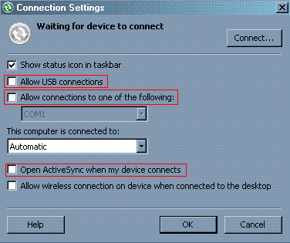

3. Connect your phone and wait.

4. Download HW_VirtualSerialPort.zip and install it.

5. Launch the HW VirtualSerialPort and do the following (do NOT worry about the TEA Key).

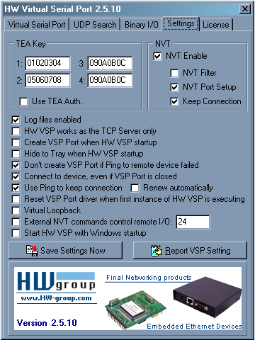

7. Open a Command Prompt and type in ipconfig /all and locate the Windows Mobile Device.
8. Get the "DHCP Server" IP.
9. Put the IP you got from the command prompt and put it into the RED box.
10. Put 13000 as the port number in both "Port" and "Server Port" as shown in the YELLOW box in the picture.
11. Pick a port from 1-20 from the GREEN box (as long as you KNOW it's open).
12. Hit "Create COM" outlined in LIGHT BLUE.

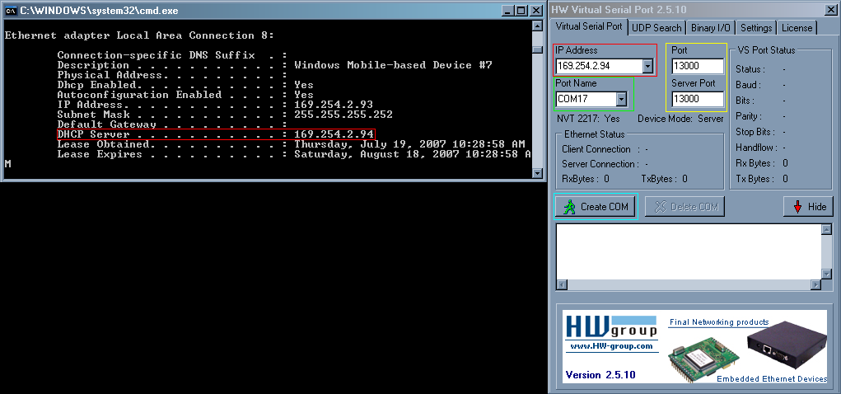

13. Open QPST Configuration and add the COM Port you just created...
14. Have fun.

